# Keywords, Identifier, Literals, Operators and Expression Assignment

**Mandatory:**

1. Choose all valid identifiers
   1. int int

Not valid. "int" is a keyword and cannot be used as an identifier.

* 1. int _numvalue

Valid. It starts with an underscore, which is allowed in C, and follows proper identifier naming rules.

* 1. float price_money

Valid. This is a correct identifier that follows the rules.

* 1. char name1234567890123456789012345678901234567890

Valid, but impractical. Although it is a valid identifier because it only contains letters, digits, and underscores, it is far too long and may cause readability or other issues.

* 1. char name value

Not valid. Identifiers cannot contain spaces.

* 1. char $name

Valid. In C, the dollar sign ($) is a valid character in identifiers, though it is rarely used.

1. What is the meaning of the following keywords, show the usage
   1. Auto

Meaning: auto is used to define automatic variables in C. By default, local variables are automatically auto. This keyword is rarely used nowadays since the default behaviour is the same.

**Ex: auto int x=5;**

* 1. Extern

Meaning: extern is used to declare a variable or function that is defined in another file. It allows access to variables/functions across different files.

**EX: extern int num;**

* 1. Volatile

Meaning: volatile tells the compiler that a variable can be changed unexpectedly, e.g., by hardware or a different thread. The compiler won't optimize the use of that variable.

**EX: volatile int counter;**

* 1. Sizeof

Meaning: sizeof is an operator used to determine the size (in bytes) of a data type or variable.

**printf("Size of int: %zu", sizeof(int));**

* 1. Const

Const is used to declare a constant variable whose value cannot be modified after initialization.

**Ex: const int max_value = 100;**

1. Explain the difference between the following variables.
   1. char *ptr = “ABC”;
   2. char arr[]=”ABC”;

**This declares a pointer ptr that points to the first character of a string literal "ABC".**

**This creates a character array arr that stores the string "ABC" with a null terminator \0 at the end.**

Can you manipulate the contents of ptr? Why?

* **You can change where ptr points, but you cannot modify the string literal i.e the contents of "ABC", as string literals are typically stored in read-only memory.**

Can you manipulate the contents of arr? Why?

* **Yes, you can modify the contents of the array, e.g., arr[0] = 'X';, because arr is a modifiable array in memory.**

Which one of the above is a string literal?

* **"ABC" is a string literal**.

1. Predict the output of the following code .

void main()

{

//set a and b both equal to 5.

int a=5, b=5;

//Print them and decrementing each time.

//Use postfix mode for a and prefix mode for b.

printf("\n%d %d",a--,--b);

printf("\n%d %d",b++,--b);

}

**OUTPUT**

**5 4**

**4 3**

1. Refer the code snippet. It fails with error. Fix it.

#include<stdio.h>

int main()

{

int i,k;

const int num;

/* for(i = 0;i < 9;i++)

{

k = k + 1;

} */

num = num + k; /* Compiler gives the error here */

printf("final value of k:%d\n",k);

printf("value of num:%d\n",num);

return 0;

}

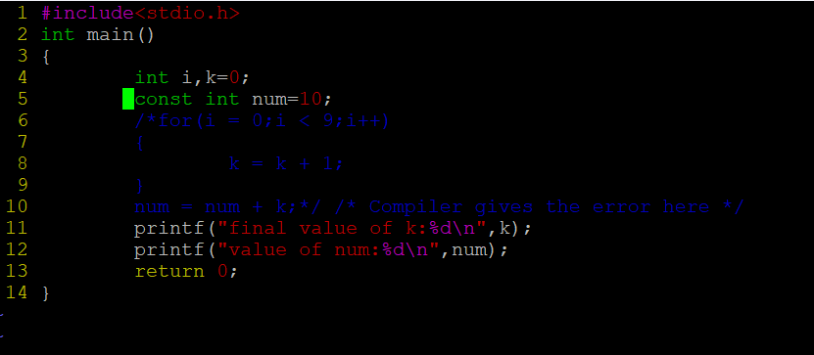

6. Consider the following code snippet. Evaluate the value of f1, f2 and f3.

int main()

{

int i = 10;

int j = 3;

float f1 = i / j;

float f2 = (float ) i / j;

float f3 = (float ) (i / j);

}

**F1 =3.0**

**F2=3.3333**

**F3=3.0**